Vernon Hills Park District
Public Notice
Emergence of the “Gentle Giant” Cicada Killer Wasp (Sphecius speciosus)
Beginning the week of 7/17/2017 the Cicada Killer Wasps have begun to emerge and be spotted around the parks. These large, intimidating wasps are uninterested in humans and don’t act aggressively unless threatened. The biggest danger these wasps pose is if stepped on by bare feet or handled roughly. All wild animals should be treated with caution, and these wasps should not be handled. With this caution in mind the Cicada Killers have a fascinating life cycle that park goers can appreciate from a safe distance.
Appearance:
Cicada Killers are one of the largest species of wasps in the Eastern United States. These wasps can grow up to 2 inches long, with females being generally larger than males. Their abdomen (back section) is a long oval shape tapering to a point at its stinger.
The coloration of the abdomen is black with three distinctive, irregular yellow bands that appear broken in the middle. Their thorax (middle section) and head are black in color with reddish accents. The Cicada Killers have 6 pairs of legs and two pairs of wings that are reddish brown in color. The forewings begin in the thorax and extend almost the entire length of the wasp.
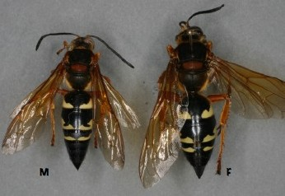_{[2]}
Life Cycle and Behavior
Cicada Killers earned their name through their use of Cicadas as food for their larva. They emerge from burrows in the ground in June and July and live for around 2.5 months, dying off in the fall.
Males may seem more aggressive than females but are not hostile towards humans, though they may investigate people in their territory. Fortunately males lack stingers. Male cicada killer wasps primarily defend their territory from other insects or appear in groups competing for females. ^{[1]}
Female wasps are solitary; after they emerge they fly close to the ground looking for a good location to form a burrow. These burrows will serve as a safe location to lay their eggs and store cicada they have captured. After Cicada Killers have dug a burrow they will begin to hunt Cicada, attacking and paralyzing them with their stingers.
Cicada can be up to twice the weight of an adult wasp so dragging the paralyzed insect back to the burrow is a difficult task. Despite this the wasps can have many cells in the burrow, each with Cicadas and an individual egg.
Cicada wasps have some control the sex of their eggs, and will store multiple Cicadas in the cells of the larger growing female larva. These eggs hatch in 24 to 48 hours and feed on the Cicadas, which unfortunately for the Cicadas doesn’t immediately kill them. Once sufficiently large enough the larva will pupate over the winter and emerge again the following summer as adult wasps! ^{[1]}
Despite all the effort that adult Cicada Killer Wasps dedicate to hunting, they actually feed on the nectar of flowers.
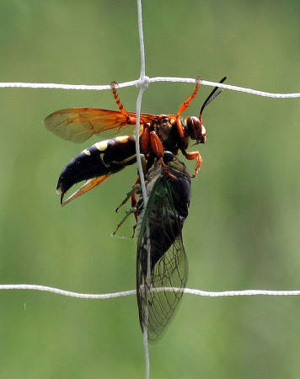_{[3]}
Habitat:
Cicada Killers can be found in the Eastern and Midwestern United States. The females look for burrowing areas in soft or sandy soil where water will easily drain away. They also prefer to burrow near trees that Cicadas might emerge from. This means that they can be found in parks around volleyball courts and baseball field or other recreational areas.

Cicada Killers and the Park District:
While these wasps may look scary, they generally don’t bother humans unprovoked. Because of this the Vernon Hills Park district doesn’t attempt to control them. If you see a Cicada Killer you should remember that these gentle giants aren’t interested in you so the best course of action is to leave them to their activities!

References
[1] Charles A Dambach and Eugene E. Good (1943) Life History and Habits of the Cicada Killer in
Ohio. v43 n1 (January, 1943), 32-41 http://hdl.handle.net/1811/3297
[2] Chuck Holliday / Wikimedia Commons / Public Domain
[3] Bill Buchanan / U.S. Fish and Wildlife Service / Public Domain
[4] Rick Krocza / Vernon Hills Park District

