**PALS South**

**Newsletter**



**August/September 2019**

**PALS South: 847-769-2683**

**Site Director**: Maureen Hilliard

**Instructors:** Shobhana, Shannon, Rani, Erika, Ujwala, Rajani, Natalie, Yamell, Gloria

**Should your child be absent from PALS, please text or call**

**847-769-2683 0r email maureenh@vhparkdistrict.org**

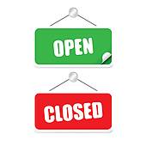

**Notes:**

**AM**: 6:00am until 8:10am **PM:** 3:00 pm until 6:00pm

**AM Drop Off and PM pick up**:

The north doors on the north side of Elementary South facing the playground. RING THE WHITE DOORBELL.

**Reminder**

* Please have your ID

ready for the first several weeks when picking up your child until all of us have had a chance to meet you. Thank you.

Be on the look out for our

September activities calendar.

“GETTING TO KNOW

YOU GAMES AND CRAFTS”

**Electronics**

**We have similar rules/policies regarding cell phones and technology as school. Cell phones, Ipads and other electronics are not allowed to be used during PALS. If a student needs to use them for their homework they will be allowed. Students must inform us if they need to use electronics for this purpose.**

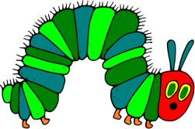

**Snacks:**

We provide a small snack in the AM and PM Program.

All of our snacks are peanut and tree nut free.

Please feel free to bring in your own snack as well- the kids get hungry when they are having fun!

