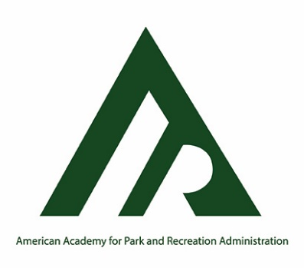
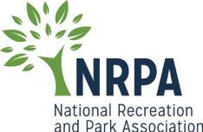
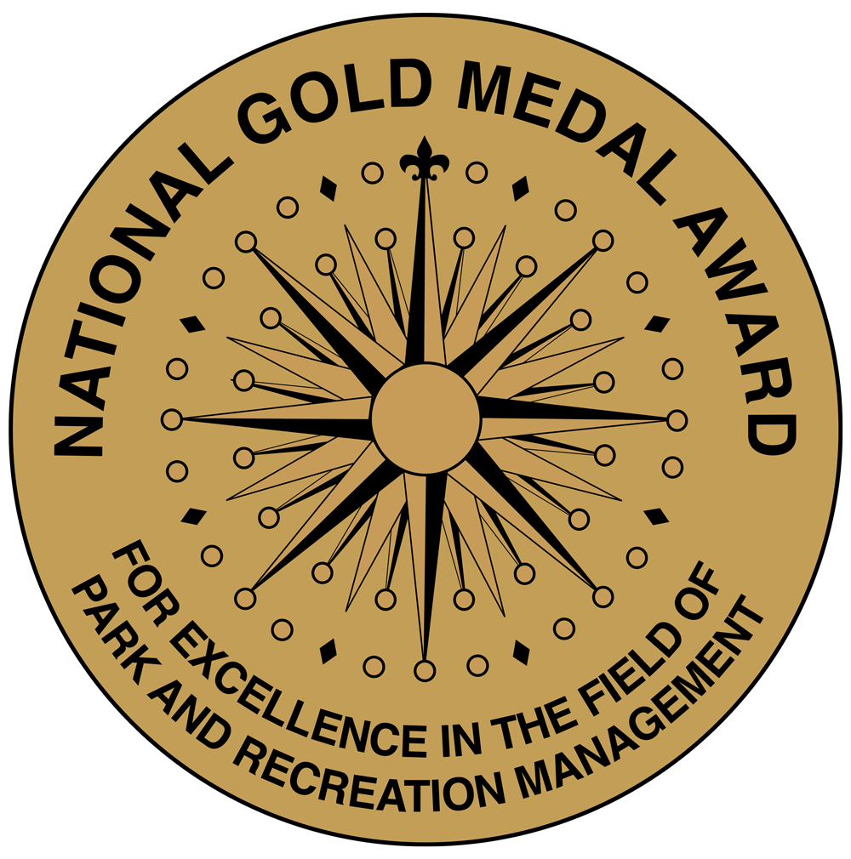

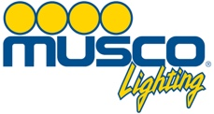

FOR IMMEDIATE RELEASE
Cheryl Buhmann, Marketing & Communications Manager
847-996-6933
cherylb@vhparkdistrict.org

Vernon Hills Park District Announced as Finalist for the 2021 National Gold Medal Awards
in Parks and Recreation Management

Vernon Hills Park District to compete for prestigious honor in the park and recreation industry

Vernon Hills, IL, May 10, 2021 – The American Academy for Park and Recreation Administration (AAPRA), in partnership with the National Recreation and Park Association (NRPA), is pleased to announce Vernon Hills Park District as a finalist for the 2021 National Gold Medal Awards for Excellence in Park and Recreation Management. Musco Lighting, LLC is proud to continue its 20+ years of sponsoring the National Gold Medal Awards program.

Founded in 1965, the National Gold Medal Awards program honors communities in the United States that demonstrate excellence in parks and recreation through long-range planning, resource management, volunteerism, environmental stewardship, program development, professional development and agency recognition. Applications are separated into six classes, with five classes based on population and one class for armed forces.

AAPRA Executive Director Jane H. Adams shared, “Each Finalist is congratulated for this prestigious award. We know local communities, state park systems, and military installations worldwide met the challenge of being responsive to the changing demands of delivering services during the COVID 19 pandemic. Park visitors and program participants have come to rely upon their service provider for physical, mental, and emotional support during this pandemic. The Academy congratulates each Finalist for their management excellence during this unprecedented time.”

Vernon Hills Park District is a finalist in the Class V category, population less than 30,000.

For nearly 50 years, the Vernon Hills Park District continues to bring memorable experiences and enjoyment to all ages through diverse programming promoting healthy lifestyles. Today the District encompasses five facilities, ten miles of recreational paths, and twenty-five parks situated on 460 acres of land. Through the collaborative efforts of the Park Board, professional staff, generous sponsors and dedicated volunteers, the District is an award recipient of the 2019-2024 Illinois Distinguished Accredited Agency Award.

Agencies are judged on their ability to address the needs of those they serve through the collective energies of community members, staff members and elected officials. Vernon Hills Park District joins three other finalists in their class that will compete for Grand Plaque which will be awarded in September.

Park Board President David Doerhoefer states “The Vernon Hills Park District is excited and honored to be an NRPA Gold Medal Finalist and we look forward to sharing our story and successes with park and recreation agencies across the country”.

A panel of five highly qualified park and recreation professionals will review and judge all application materials. Judges are chosen for their considerable experience and knowledge in parks and recreation on both the local and national levels.

This year’s finalists will compete for the Grand Plaque Award honors this summer, and seven Grand Plaque recipients will be announced during the 2021 NRPA Conference, which will be held virtually and in person September 21-23 in Nashville, Tennessee. The presentation of both the Finalist and Grand Plaque recipients is being finalized and details will be forthcoming.

For more information on the National Gold Medal Award Program, visit www.aapra.org.

###

The American Academy for Park and Recreation Administration is a nonprofit organization founded to advance knowledge related to the administration of recreation and parks; to encourage scholarly efforts by both practitioners and educators that would enhance the practice of park and recreation administration; to promote broader public understanding of the importance of parks and recreation to the public good; and, to conduct research, publish scholarly papers and sponsor seminars related to the advancement of park and recreation administration. For more information, visit www.aapra.org.

Partner: The National Recreation and Park Association
The National Recreation and Park Association is a national not-for-profit organization dedicated to ensuring that all people have access to parks and recreation for health, conservation and social equity. Through its network of 60,000 recreation and park professionals and advocates, NRPA encourages the promotion of healthy and active lifestyles, conservation initiatives and equitable access to parks and public space. For more information, visit www.nrpa.org. For digital access to NRPA’s flagship publication, Parks & Recreation, visit www.parksandrecreation.org.

Sponsor: Musco Lighting, LLC is a company that has specialized in lighting systems for sports and large areas for more than 30 years. Musco has pioneered dramatic improvements in energy efficiency and affordable ways to control wasted spill light and glare. Permanent and temporary lighting services range from neighborhood fields to NASCAR super speedways. For more information, visit www.musco.com.

